**SESSION 26 – Admin Screens:**

In this session, topics covered are:

Update Referer

Field Configuration

Collaboration

Update Belonging

SSIS Configuration

**Update Referer:**

Menu -> Configuration -> Update Referer

Update referer is used to refer the individual from one to other to provide the details behalf of them and also used to refer the individual for incentives, also we can update the referrer by using edit option.

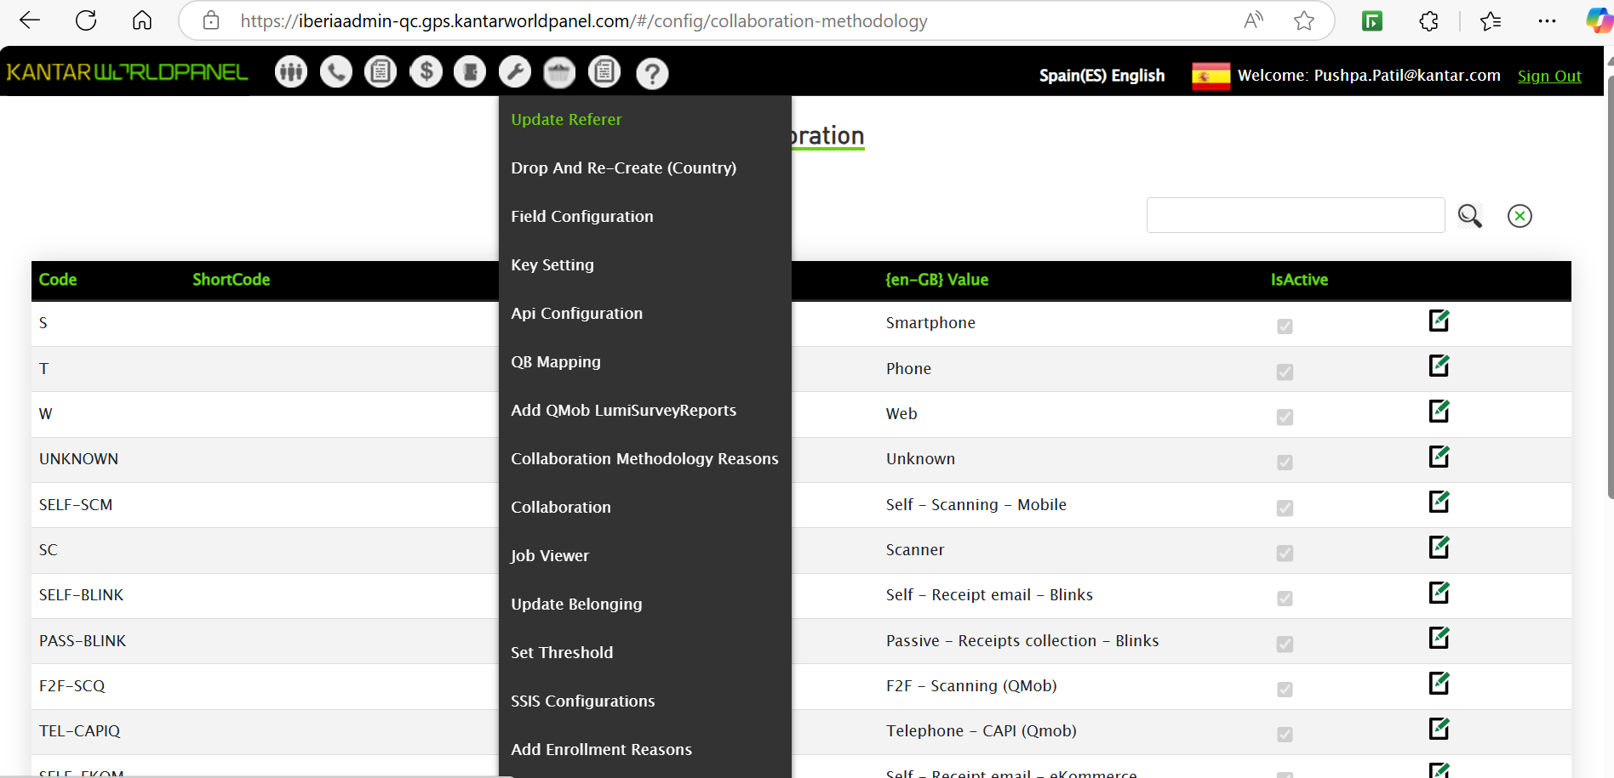

We can see below that the 770000-00 is referrer for 823882-00 where it can be referred to provide the details and we can edit the referer by using edit option.

**Field Configuration:**

Menu -> Configuration -> Field Configuration.

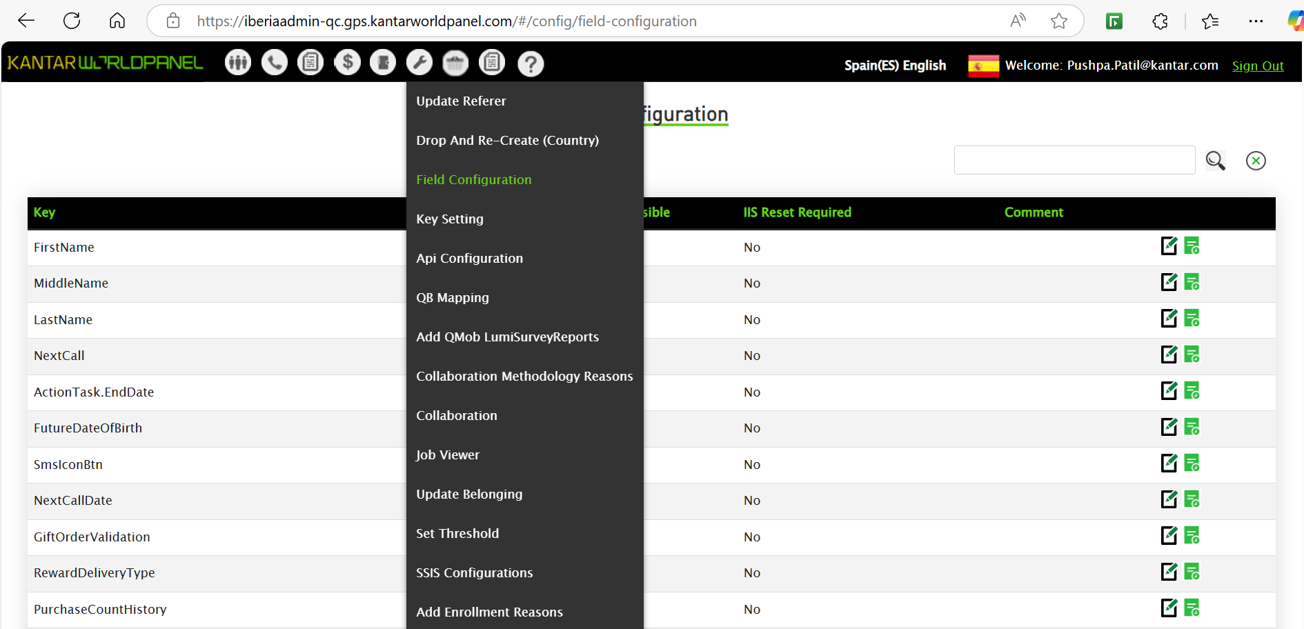

Field configuration is used to configure and handle the different fields of menu based on the access and role user has and control the field and also to hide the fields from the users.

The field change will be reflecting once we restart the pods, it will be taken care by Dev team.

example: if we want user to make visible different field or not whether the files are required or not.

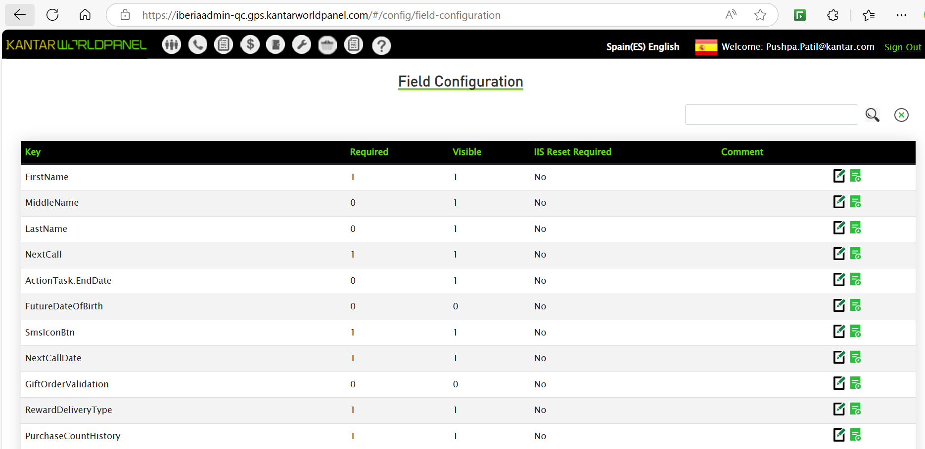

**Collaboration:**

Menu -> Configuration -> Collaboration

Collaboration is used to update the collaboration methodology, the method panel manager can contact the panellist and perform specific actions.

Example: phone, web, email

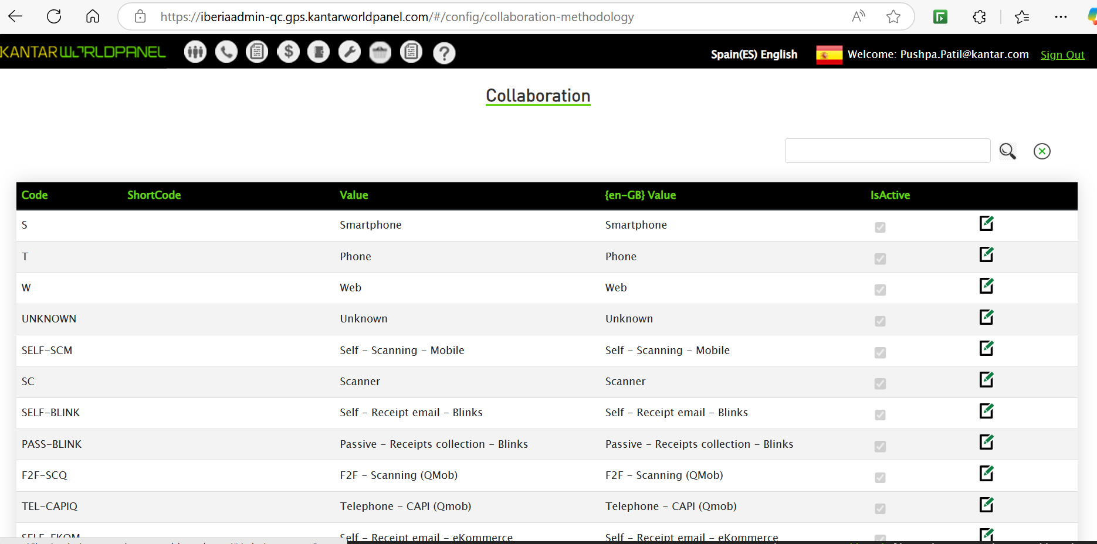

**Update Belonging:**

Menu-> Configuration -> Update Belongings

It is used to update the belongings of the individual, if the user has incorrectly updated the belongings or details then the user can correct the details from the admin screen.

Provide the group id, it will fetch the individuals of that group and belongings of that individuals, we can update or delete the belonging of the individual.

**SSIS configurations:**

Menu -> Configuration-> SSIS Configuration

It is used for data processing, how the data is extracted from multiple sources (databases, flat files or APIs), It also used for data synchronization.

We see below that files are uploaded and sent to mentioned email ids from SSIS.

It used to automate data imports and exports in scheduled batches, reducing manual data entry effort and ensure data consistency.

